Practical no:4

a.css properties to change the background of the page.

b..css properties to change the font and text Styles.

a.program

<!doctype html>

<html>

<head><title>External css</title>

<LINK rel="Stylesheet" type="text/CSS" href="bgpropertiescss.css">

</head>

<body>

<h1>This web page use border of css</h1>

<div id=d1>

<p>Casceding Style sheets<br>the presentation of a documents written<br>world wide web<br></p></div></br></br>

<div id=d2>

<p>website to<br>css sheet<br>your<br>each page<br></p></div></br></br>

<div id=d3>

<p>haed section<br>apply style<br>the code<br>style sheet<br>inserted into<br></p></div></br></br>

</body>

</html>

Save this document by .html after open new window and type code

body

{

background-color:pink;

background-image:url("tulips.jpg");

background-repeat:repeat-y;

background-position:left top;

margin-left:250px;

background-attachment:Fixed;

background-size:200px 200px;

}

#d1{

border:2px dotted black;

padding:30px;

background:rgb(100,0,255);

}

#d2

{

border:2px dotted black;

padding:30px;

background:rgb(255,120,0);

}

#d3

{

border:2px dotted black;

padding:30px;

background:rgb(0,150,200);

}

Now save this code by .css run html file and following is the o/p

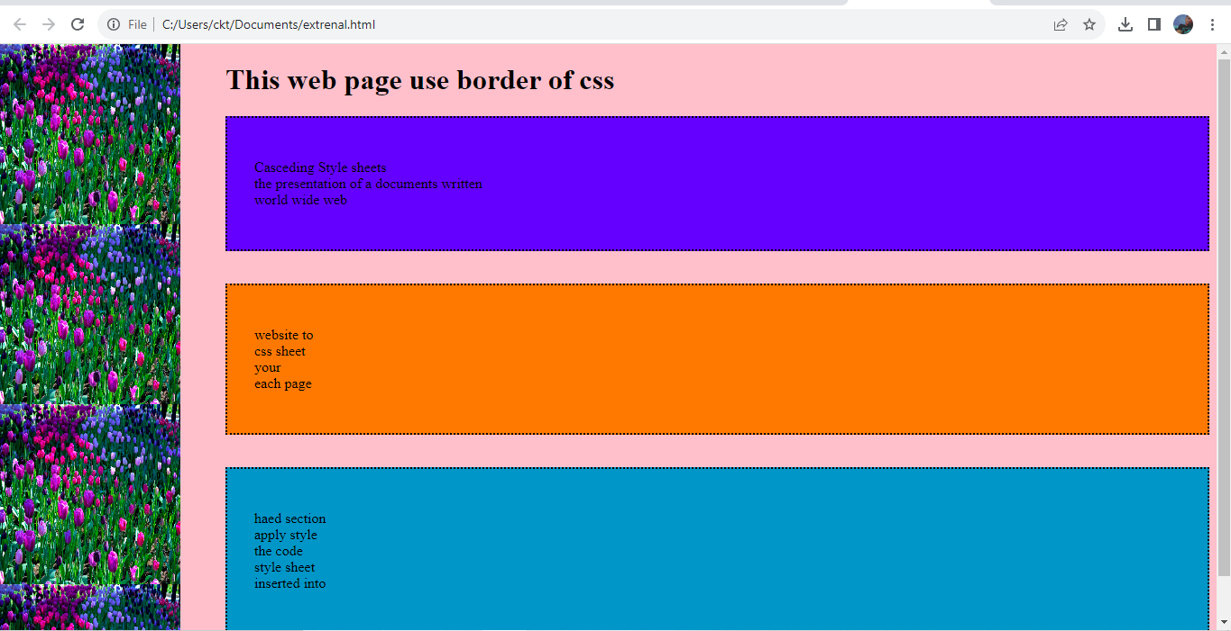

b.program

<!DOCTYPE html>

<html>

<head>

<title>Using CSS property</title>

<style>

p.normal {

font-family: "Times New Roman";

font-style: normal;

text-align: right;

}

p.static {

font-family: Arial;

font-style: italic;

text-decoration: underline;

}

#d1 {

font-weight: 300;

font-size: large;

font-variant: small-caps;

text-transform: uppercase;

}

p.d2 {

font-style: oblique;

text-shadow: 2px 4px 6px blue;

}

</style>

</head>

<body>

<p class="normal">paragraph in normal form</p>

<p class="static">This text will appear in italic style</p>

<div id="d1">Font property sets the font of the content of HTML document</div>

<p class="d2">Text property sets the text of the content of HTML document</p>

</body>

</html>

Op:

